Name: |  | ___________________________________________________ |  |  |  |  |  | Date: ___________
 |  | Year 8 Mathematics  Test 2, 2015  Topics – Length, Perimeter and Area |  |  |  |  |  | 60  = %
Total Time: |  | 60 minutes
SECTION 1: CALCULATOR FREE
Time: | 25 minutes |  | Total Marks: | 26 |  | Equipment Allowed: | Nil

1. | [2 marks: ½, ½, ½, ½ ]
 | For each of the following questions, shade the bubble below the answer you think is most correct.
a) | How many metres are there in a kilometre?
 | 10 | 100 | 1000 | 10 000 | 100 000
 | Questions b) and c) relate to the diagram below
 | 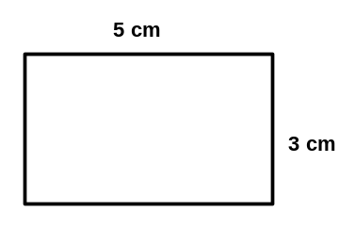
b) | The perimeter of this rectangle above is:
 | 15 cm | 8 cm | 30 cm | 12 cm | 16 cm
c) | The area of the rectangle above is:
 | 15 cm² | 16 cm² | 20 cm² | 8 cm² | 35 cm²
d) | If the length of a parallelogram’s base was 10cm and its height was 4 cm what would its area be?
 | 40 cm | 14 m | 28 cm | 40 cm² | 28 cm²

2. | [2 marks: ½, ½, ½, ½]  Match these words with the most accurate meaning.
 | Perimeter |  | Distance from one side of a circle to the other going through the centre.
 | Radius |  | The distance around the outside of a circle.
 | Diameter |  | Distance around the outside of a closed, two-dimensional shape.
 | Circumference |  | Distance from the centre of a circle to its edge.

3. | [6 marks: 1, 1, 2, 2]
 | Complete the following conversions:
a) | 52 cm = ____________ m | b) | 1.65 km = ____________ m
c) | 980 mm = ____________________ m | d) | 0.38 km = ____________________ cm

4. | [6 marks: 1, 1, 2, 2]
 | Complete the following conversions:
a) | 95 mm² = ____________ cm² | b) | 2.45 m² = ____________ cm²
c) | 75 789 mm² = ____________________ m² | d) | 0.028 km² = ____________________ cm²

5. | [2 marks]
 | If a rectangle has an area of 32 cm², give 2 possible sets of dimensions it could have.

6. | [8 marks: 1, 2, 2, 3]
 | Calculate the perimeter of the following shapes:
a) |  | b)
c) |  | d) | 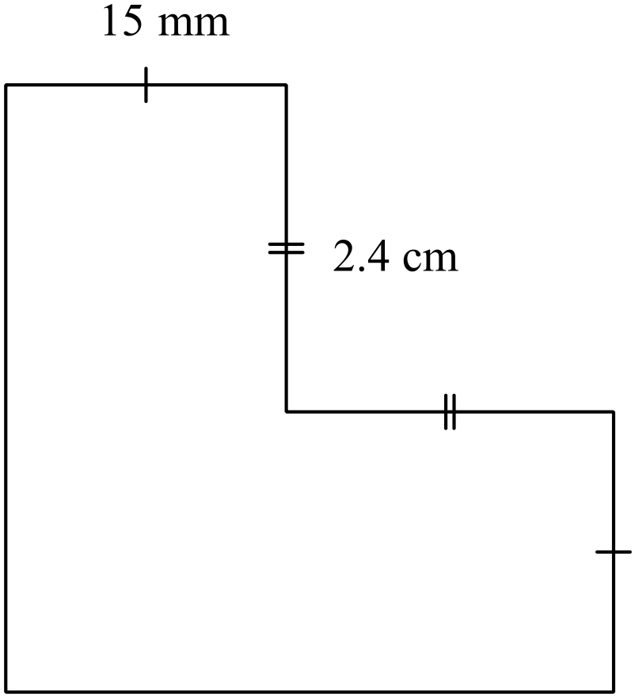

~ END OF TEST SECTION 1 ~
Name: |  | ___________________________________________________ |  |  |  |  | Date: ___________
SECTION 2: CALCULATOR ASSUMED
Time: | 35 minutes |  | Total Marks: | 34 | Equipment Allowed: | ½ page notes (A4 one side), Scientific calculator

7. | [10 marks: 1, 2, 1, 2, 2, 2]
 | Determine the area of the following:
a) | Square with side lengths of 7.5 m | b) | 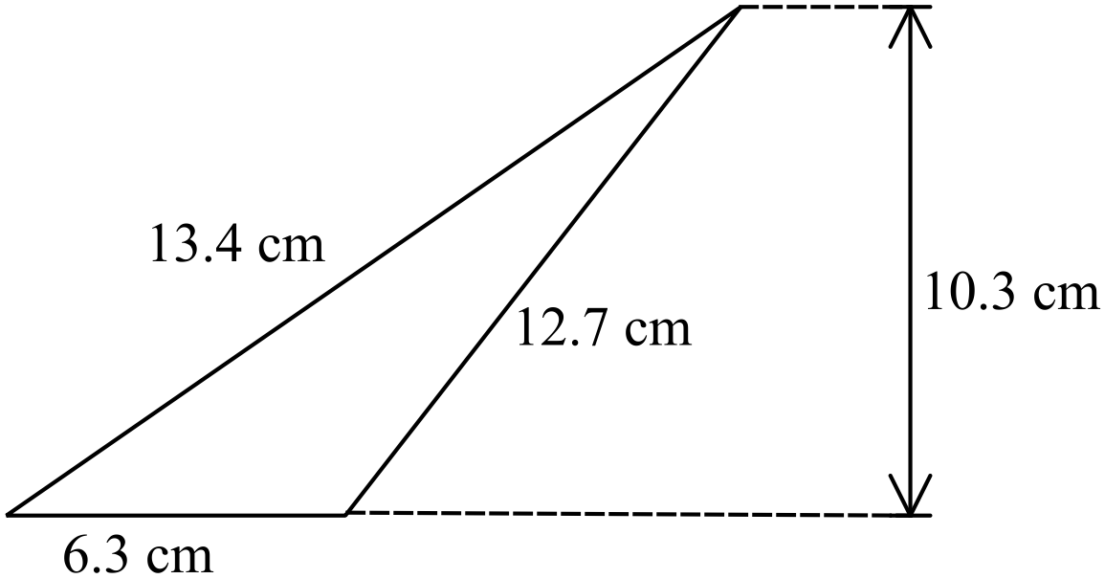
c) | Rectangle with dimensions 3.2 cm by 2.1 cm. | d) | 5 m  3 m
e) | 11 mm  8 mm | f) | 3 cm  5 cm  2 cm

8. | [3 marks]
 | Determine the area of the arch window below. Give your answer correct to two decimal places.
 | 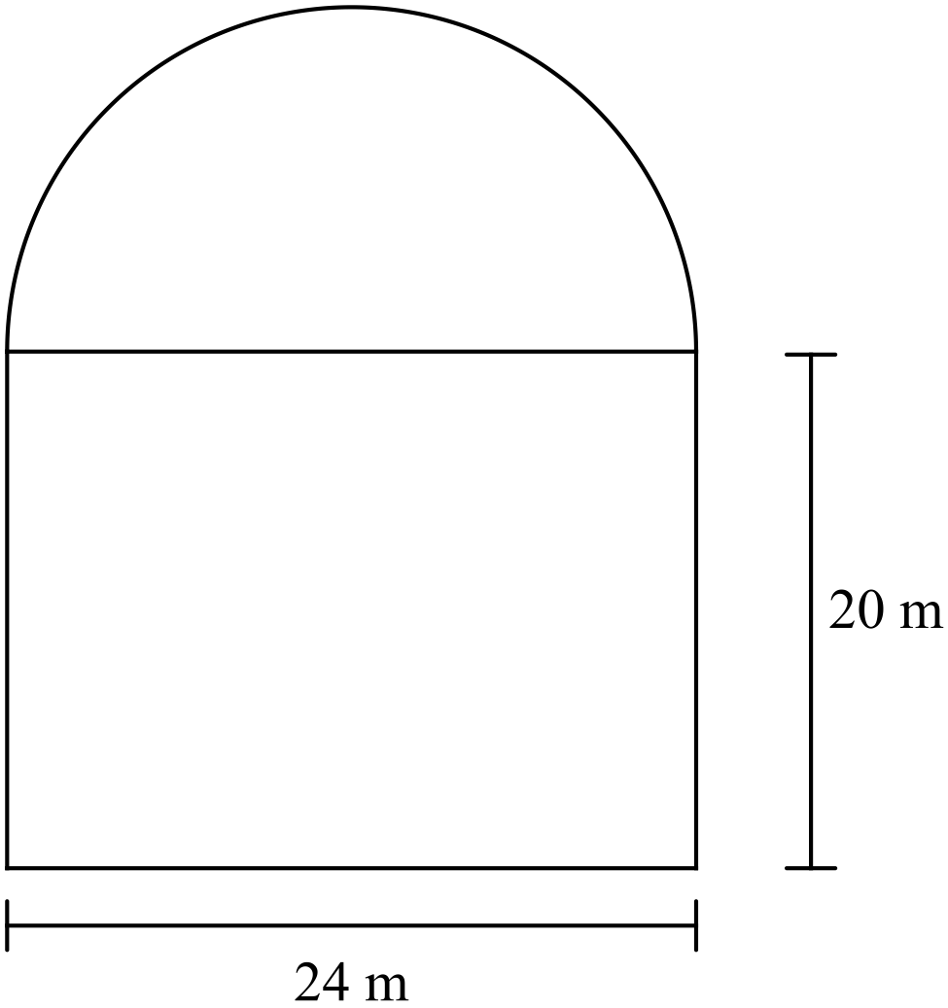

9. | [4 marks: 2, 2]
 | Determine the perimeter of the following. Round your answer correct to two decimal places.
a) | 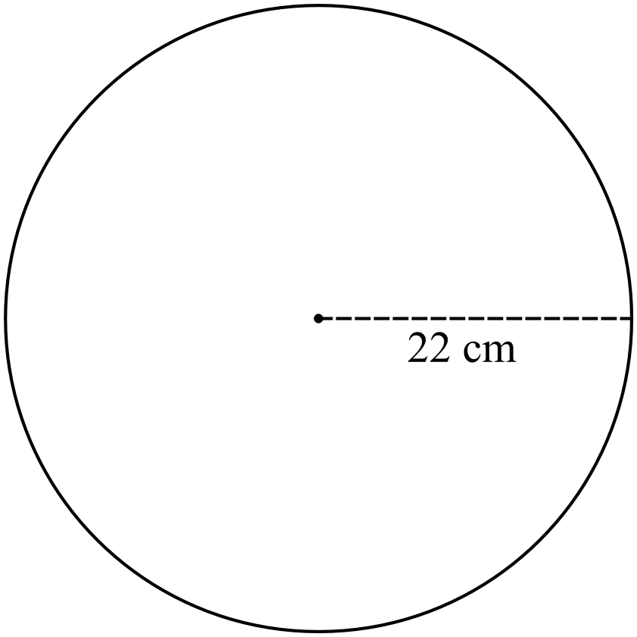 | b) | 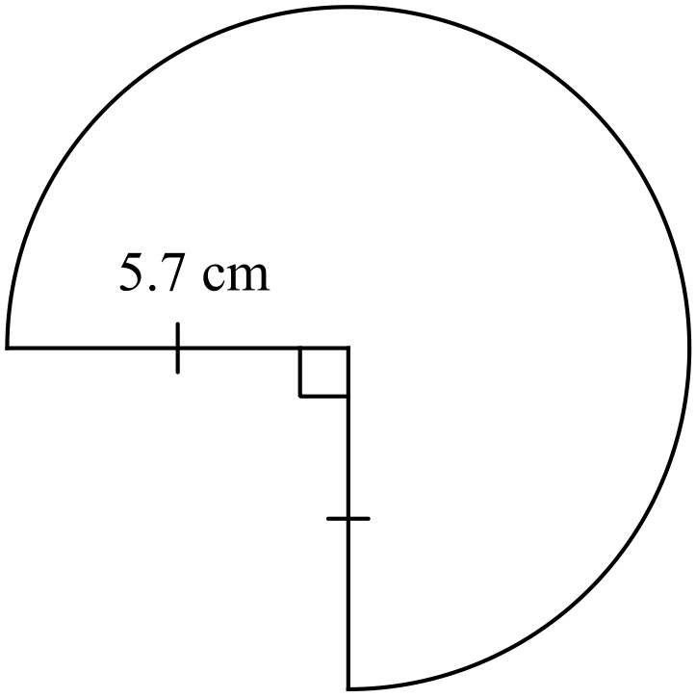

10. | [4 marks: 2, 2]
22 cm | Determine the area of the following, correct to one decimal place.
a) |  | b) | 20 cm

11. | [4 marks: 2, 2]
 | Determine the perimeter and area of the following sector, correct to one decimal place.
 | 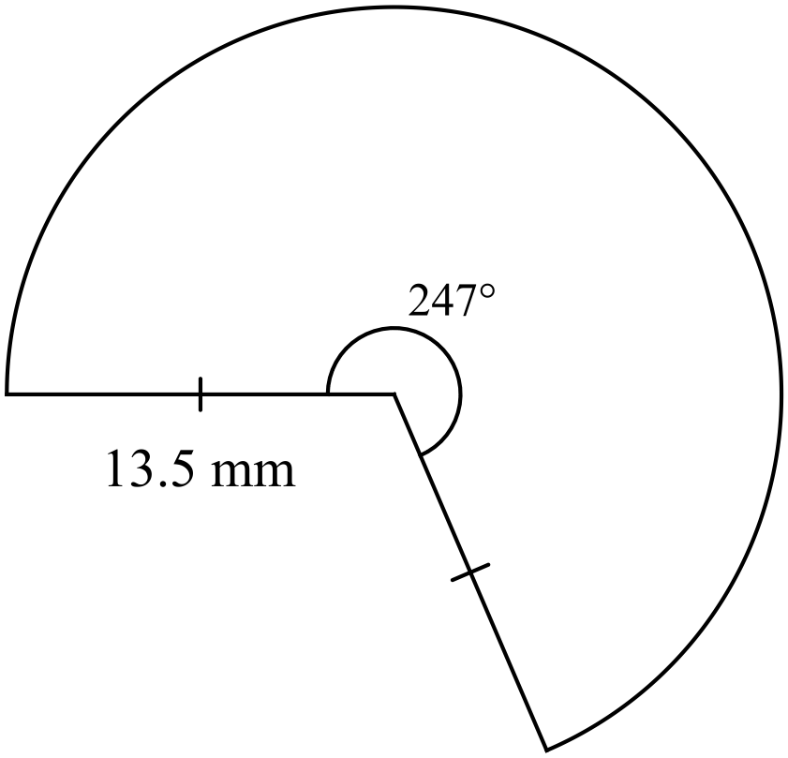 | a) | Perimeter:
 |  | b) | Area:

12. | [2 marks]
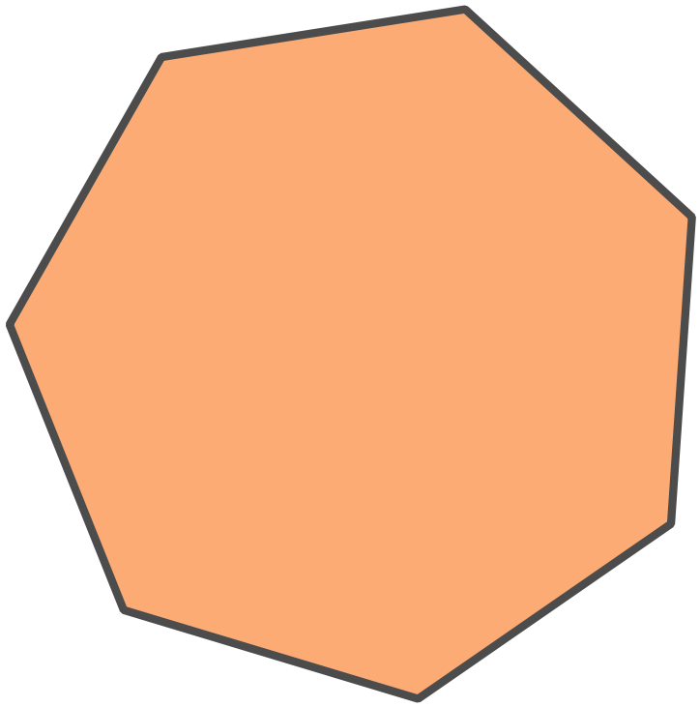A regular polygon shown has a perimeter of 112 m.
How long is each side?

13. | [2 marks]
A circle has a circumference of 18 m.
What is its radius, correct to three decimal places?

14. | [3 marks]
A triangle has been cut out of a rectangular piece of card. What area of card remains?
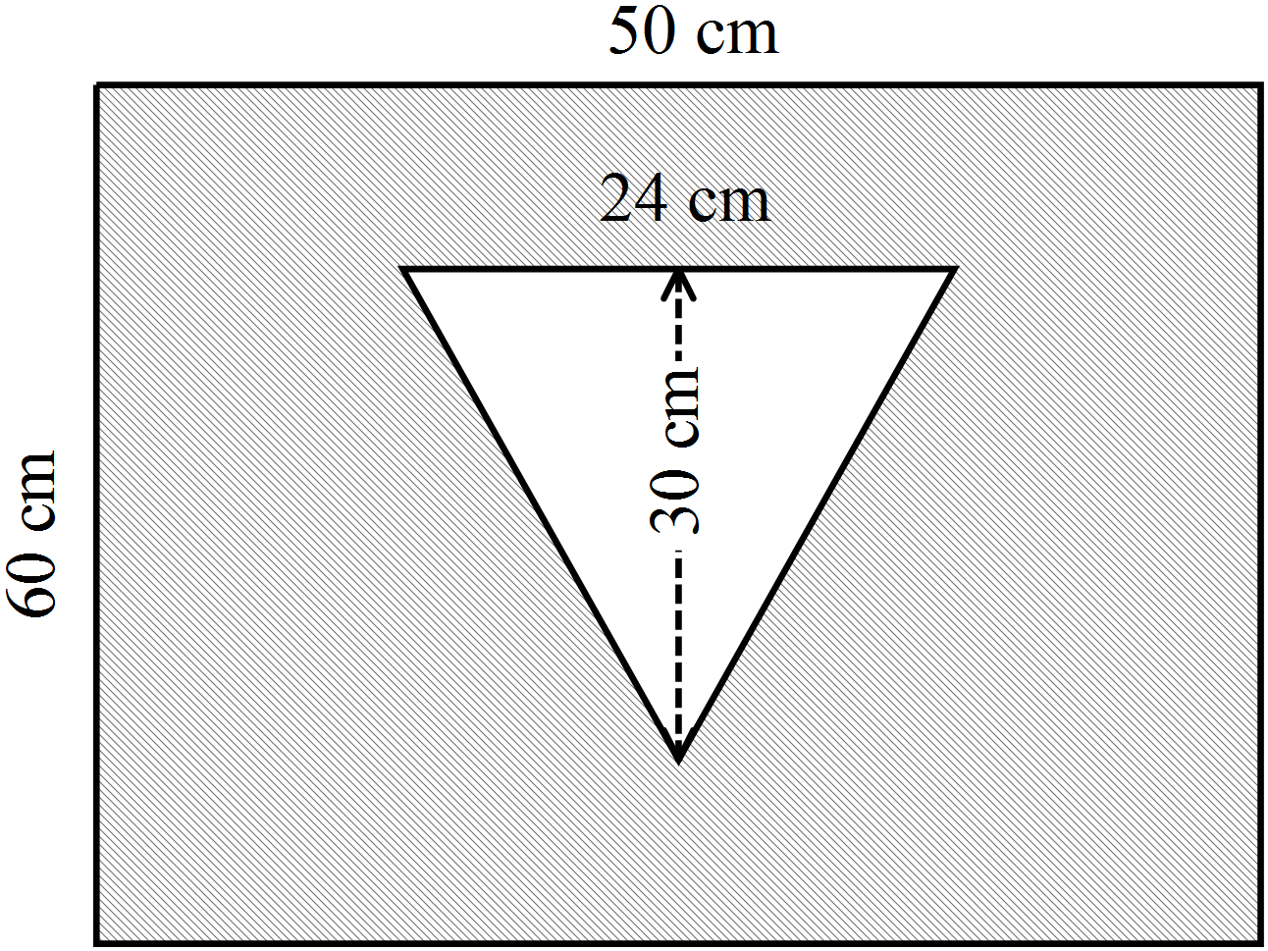

15. | [2 marks]
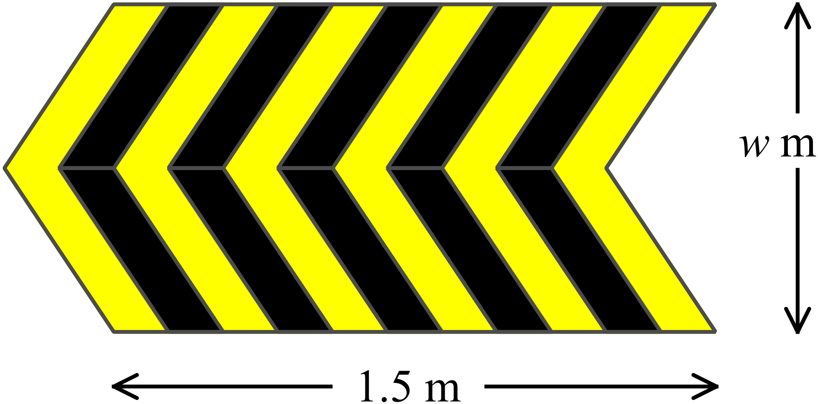A warning sign is in the shape of an arrow made up of two parallelograms, as shown.

The length of one edge of the sign is 1.5 m and it has an area of 1.8 m².

What is the width of the sign (marked w)?

~ END OF TEST SECTION 2 ~

